[CEN 323 ] Computer Organization & Assembly Language
Lab 4 Journal

Name : Fatima Asad
Enrollment Number: 01-135232-020

Lab Deliverables (submission guideline)

Create a folder named after your enrollment number and add the following files:
  - Create a folder named YourRollNumber_Lab4 containing:
- .asm files of the three practice tasks.
- Add full screen screenshots of the code and output in this word file.
  - Zip the Folder and upload to LMS.

Lab Task

Task 1:
Code (TEXT):
.model small

.data

dividend db 6
divisor db -2
dividend2 db -6
divisor2 db -2

.code

main:

mov ax,@data
mov ds,ax
mov ax,0
mov al,dividend2

CBW

IDIV divisor2
mov bl,al
mov al,dividend

CBW

IDIV divisor
mov bl,al

end main
Screenshot (CODE):
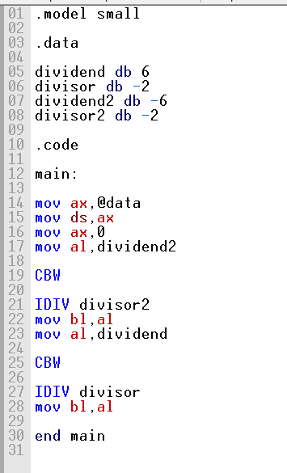

Screenshot (OUTPUT):
Negative / Negative
-6 / -2
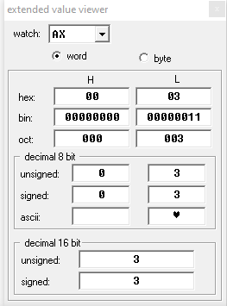
Positive/negative
6 / -2
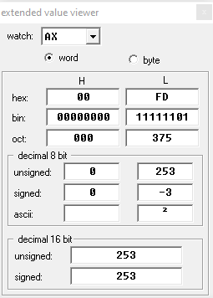
Task 2:
Code (TEXT):
.model small

.data

var1 db -2
var2 db -2
divisor db -2

msg1 db "Result of -2 x -2: $"
msg2 db "Result of 4/-2: $"

.code

main:

mov ax,@data
mov ds,ax

LEA dx,msg1
mov ah,09h
int 21h

mov ax,0
mov al,var1
IMUL var2
mov bl,al
IDIV divisor
mov bl,al

end main
Screenshot (CODE):
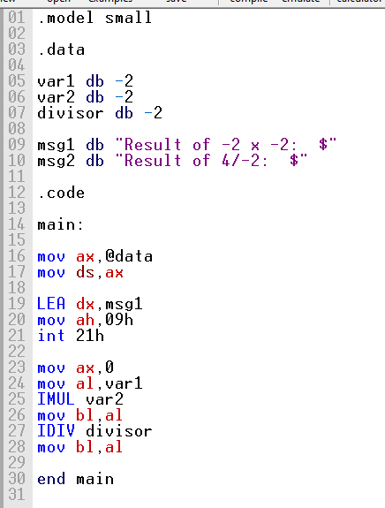

Screenshot (OUTPUT):
-2 x -2
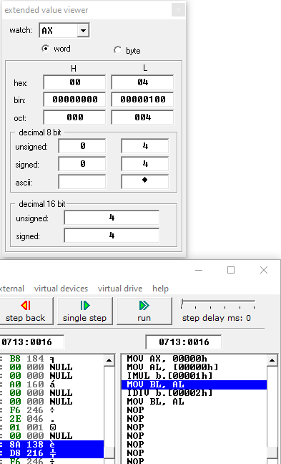
4/ -2
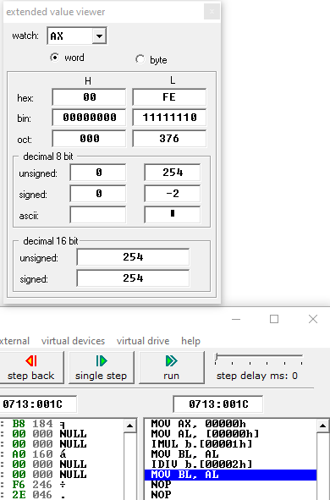

Task 3:
Code (TEXT):
.model small
.data

num1 db ?
num2 db ?
num3 db ?
hundred db 100
tens db 10
res db ?
temp db ?
space db 10,13,"$"

msg1 db "value of first number: $"
msg2 db "value of second number: $"
msg3 db "value of third number: $"
msg4 db "The number is : $"

.code

main:

mov ax,@data
mov ds,ax

mov ah,09h
LEA dx,msg1
int 21h

LEA dx,space
int 21h

xor ax,ax
mov ah,01h
int 21h

mov num1,al
sub num1,48
mov ah,09h
LEA dx,space
int 21h

mov ah,09h
LEA dx,msg2
int 21h
LEA dx,space
int 21h

xor ax,ax
mov ah,01h
int 21h

mov num2,al
sub num2,48
mov ah,09h
LEA dx,space
int 21h

mov ah,09h
LEA dx,msg3
int 21h
LEA dx,space
int 21h
xor ax,ax
mov ah,01h
int 21h
mov num3,al
sub num3,48
mov ah,09h
LEA dx,space
int 21h

xor ax,ax
mov al,num1
mul hundred
mov res,al

xor ax,ax
mov al,num2
mul tens
add res,al

mov al,num3
add res,al

mov ax,ax
mov al,res
div hundred
mov num1,al
mov temp,ah
xor ax,ax
mov al,temp
div tens

mov num2,al
mov num3,ah
add num1,48
add num2,48
add num3,48
mov ah,09h
LEA dx,msg4
int 21h

mov ah,02h
mov dl,num1
int 21h

mov dl,num2
int 21h

mov dl,num3
int 21h

mov ah,4Ch
int 21h

end main
Screenshot (CODE):
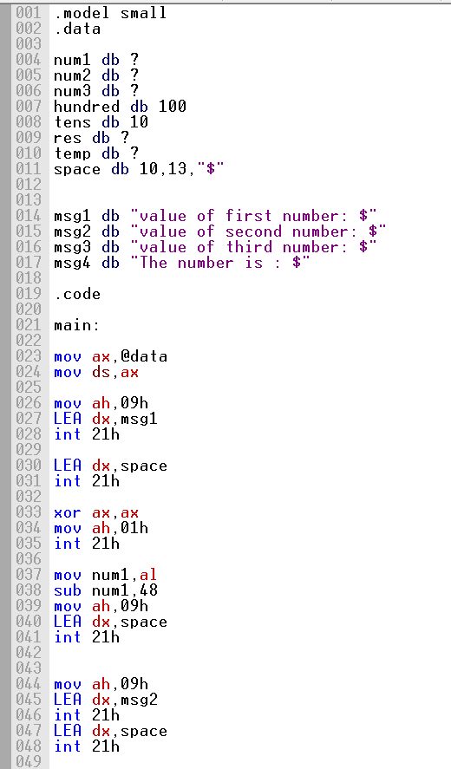
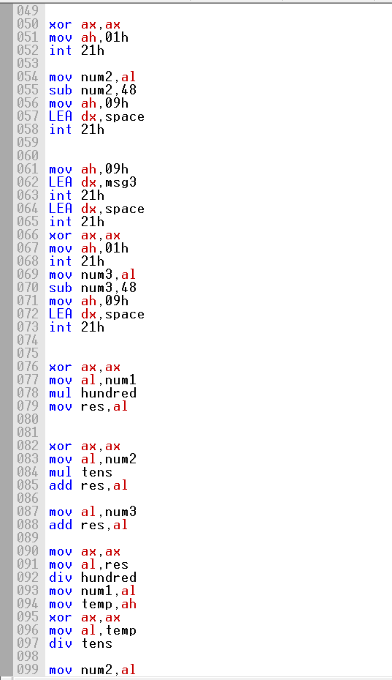

Screenshot (OUTPUT):
